**Scully and Angular Static site generator:**

**Reference:**

**1.Create a Static Site Using Angular & Scully (with Tara Z. Manicsic) — Learn With Jason 1,218 views •18 Dec 2019**

[**https://www.youtube.com/watch?v=ugTx-14jRrI&t=3107s**](https://www.youtube.com/watch?v=ugTx-14jRrI&t=3107s)

**Commands:**

**cd projects**

**cd scully-angular-jamstack-sites**

**ng --version**

**ng new jamgularOne**

? Would you like to add Angular routing? **Yes**

? Which stylesheet format would you like to use? **SCSS**  [ https://sass-lang.com/

documentation/syntax#scss

krishna@krishna-Lenovo-G50-70:~/projects/scully-angular-jamstack-sites$

**cd jamgularOne**

krishna@krishna-Lenovo-G50-70:~/projects/scully-angular-jamstack-sites/jamgularOne$

**ng serve --open**

**ng g m home --route home --module app.module.ts**

**ng g m users --route users --module app.module.ts**

**ng g m about --route about --module app.module.ts**

krishna@krishna-Lenovo-G50-70:~/projects/scully-angular-jamstack-sites/jamgularOne$

**ng g c user/users**

**************************************************************************************

**app-routing.module.ts**

import { NgModule } from '@angular/core';

import { Routes, RouterModule } from '@angular/router';

**const routes: Routes = [{ path: '', loadChildren: () => import('./home/home.module').then(m => m.HomeModule) }, { path: 'users', loadChildren: () => import('./users/users.module').then(m => m.UsersModule) }, { path: 'about', loadChildren: () => import('./about/about.module').then(m => m.AboutModule) }];**

@NgModule({

imports: [RouterModule.forRoot(routes)],

exports: [RouterModule]

})

export class AppRoutingModule { }

**\*\*\*\*\*\*\*\*\*\*\*\*\*\*\*\*\*\*\*\*\*\*\*\*\*\*\*\*\*\*\*\*\*\*\*\*\*\*\*\*\*\*\*\*\*\*\*\*\*\*\*\*\*\*\*\*\*\*\*\*\*\*\*\*\*\*\*\*\*\*\*\*\*\*\*\*\*\*\*\*\*\*\*\*\*\*\*\*\*\*\*\*\*\*\*\*\*\*\*\*\*\*\*\*\*\*\***

**ng serve --port 4204**

**ng build**

**ng add @scullyio/init**

**npm i @scullyio/ng-lib**

**npm run scully**

Static site:

<https://relaxed-hodgkin-68afc6.netlify.com/>

1.

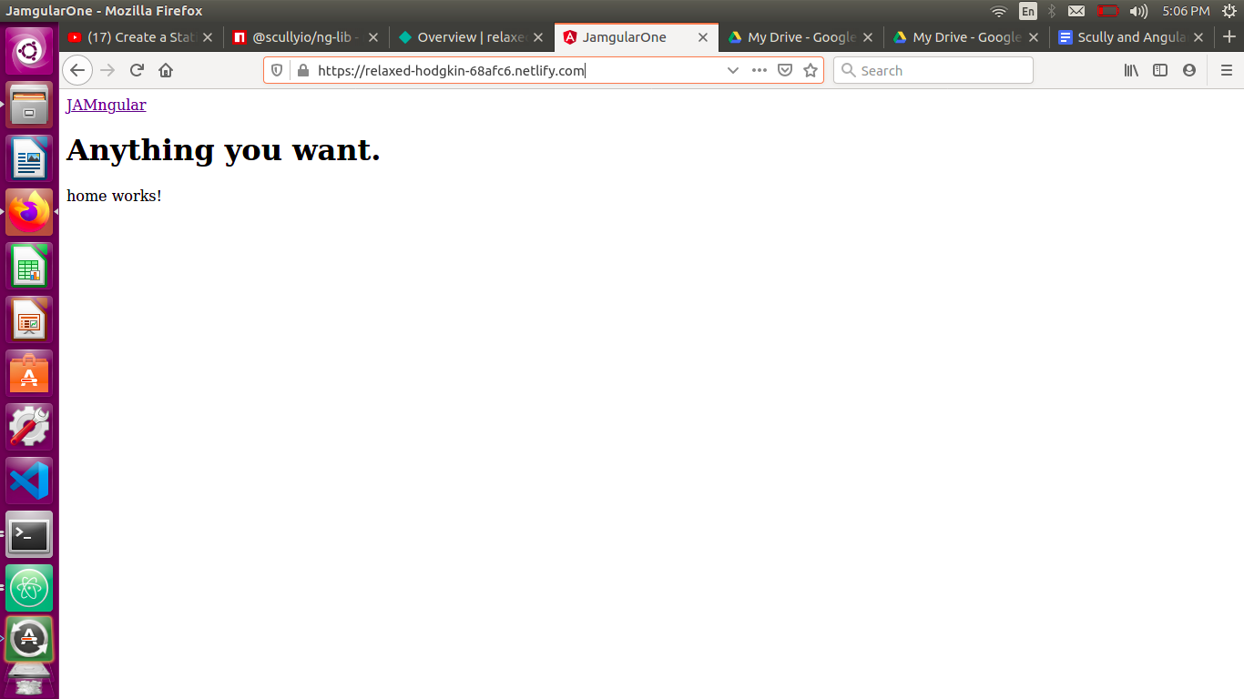

2.

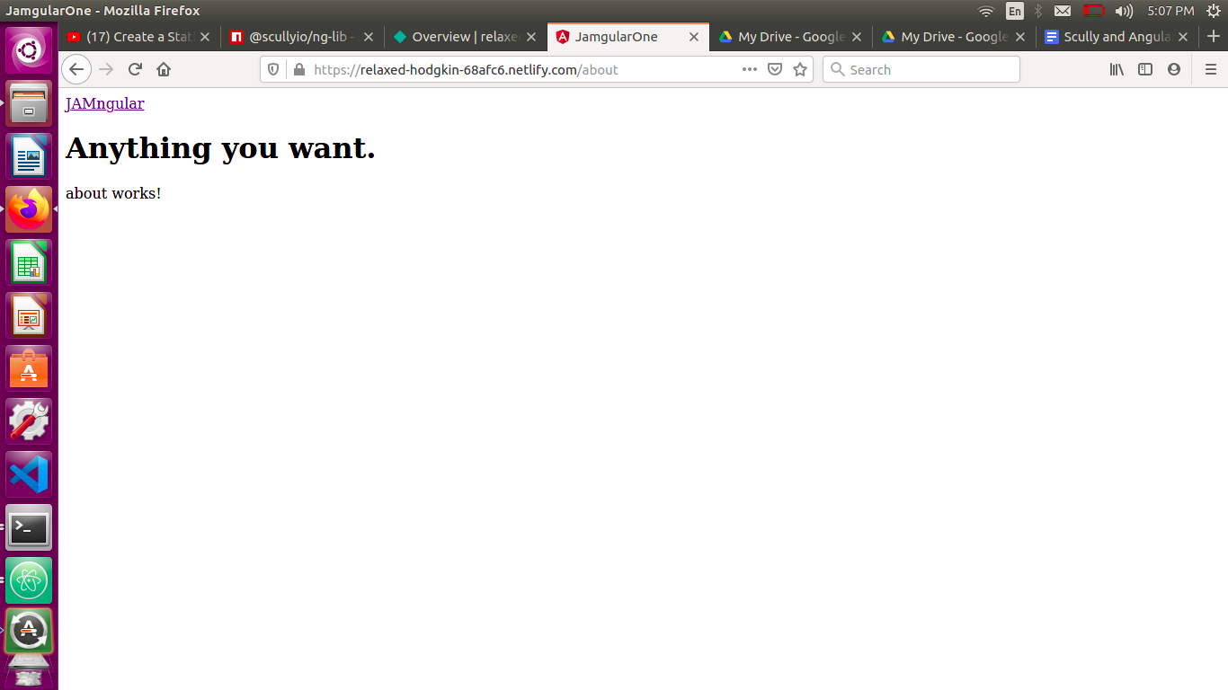

3.

